# **Practical No – 05**

# **ANOVA (Analysis of Variance)**

a) Perform one-way ANOVA to compare means across multiple groups.

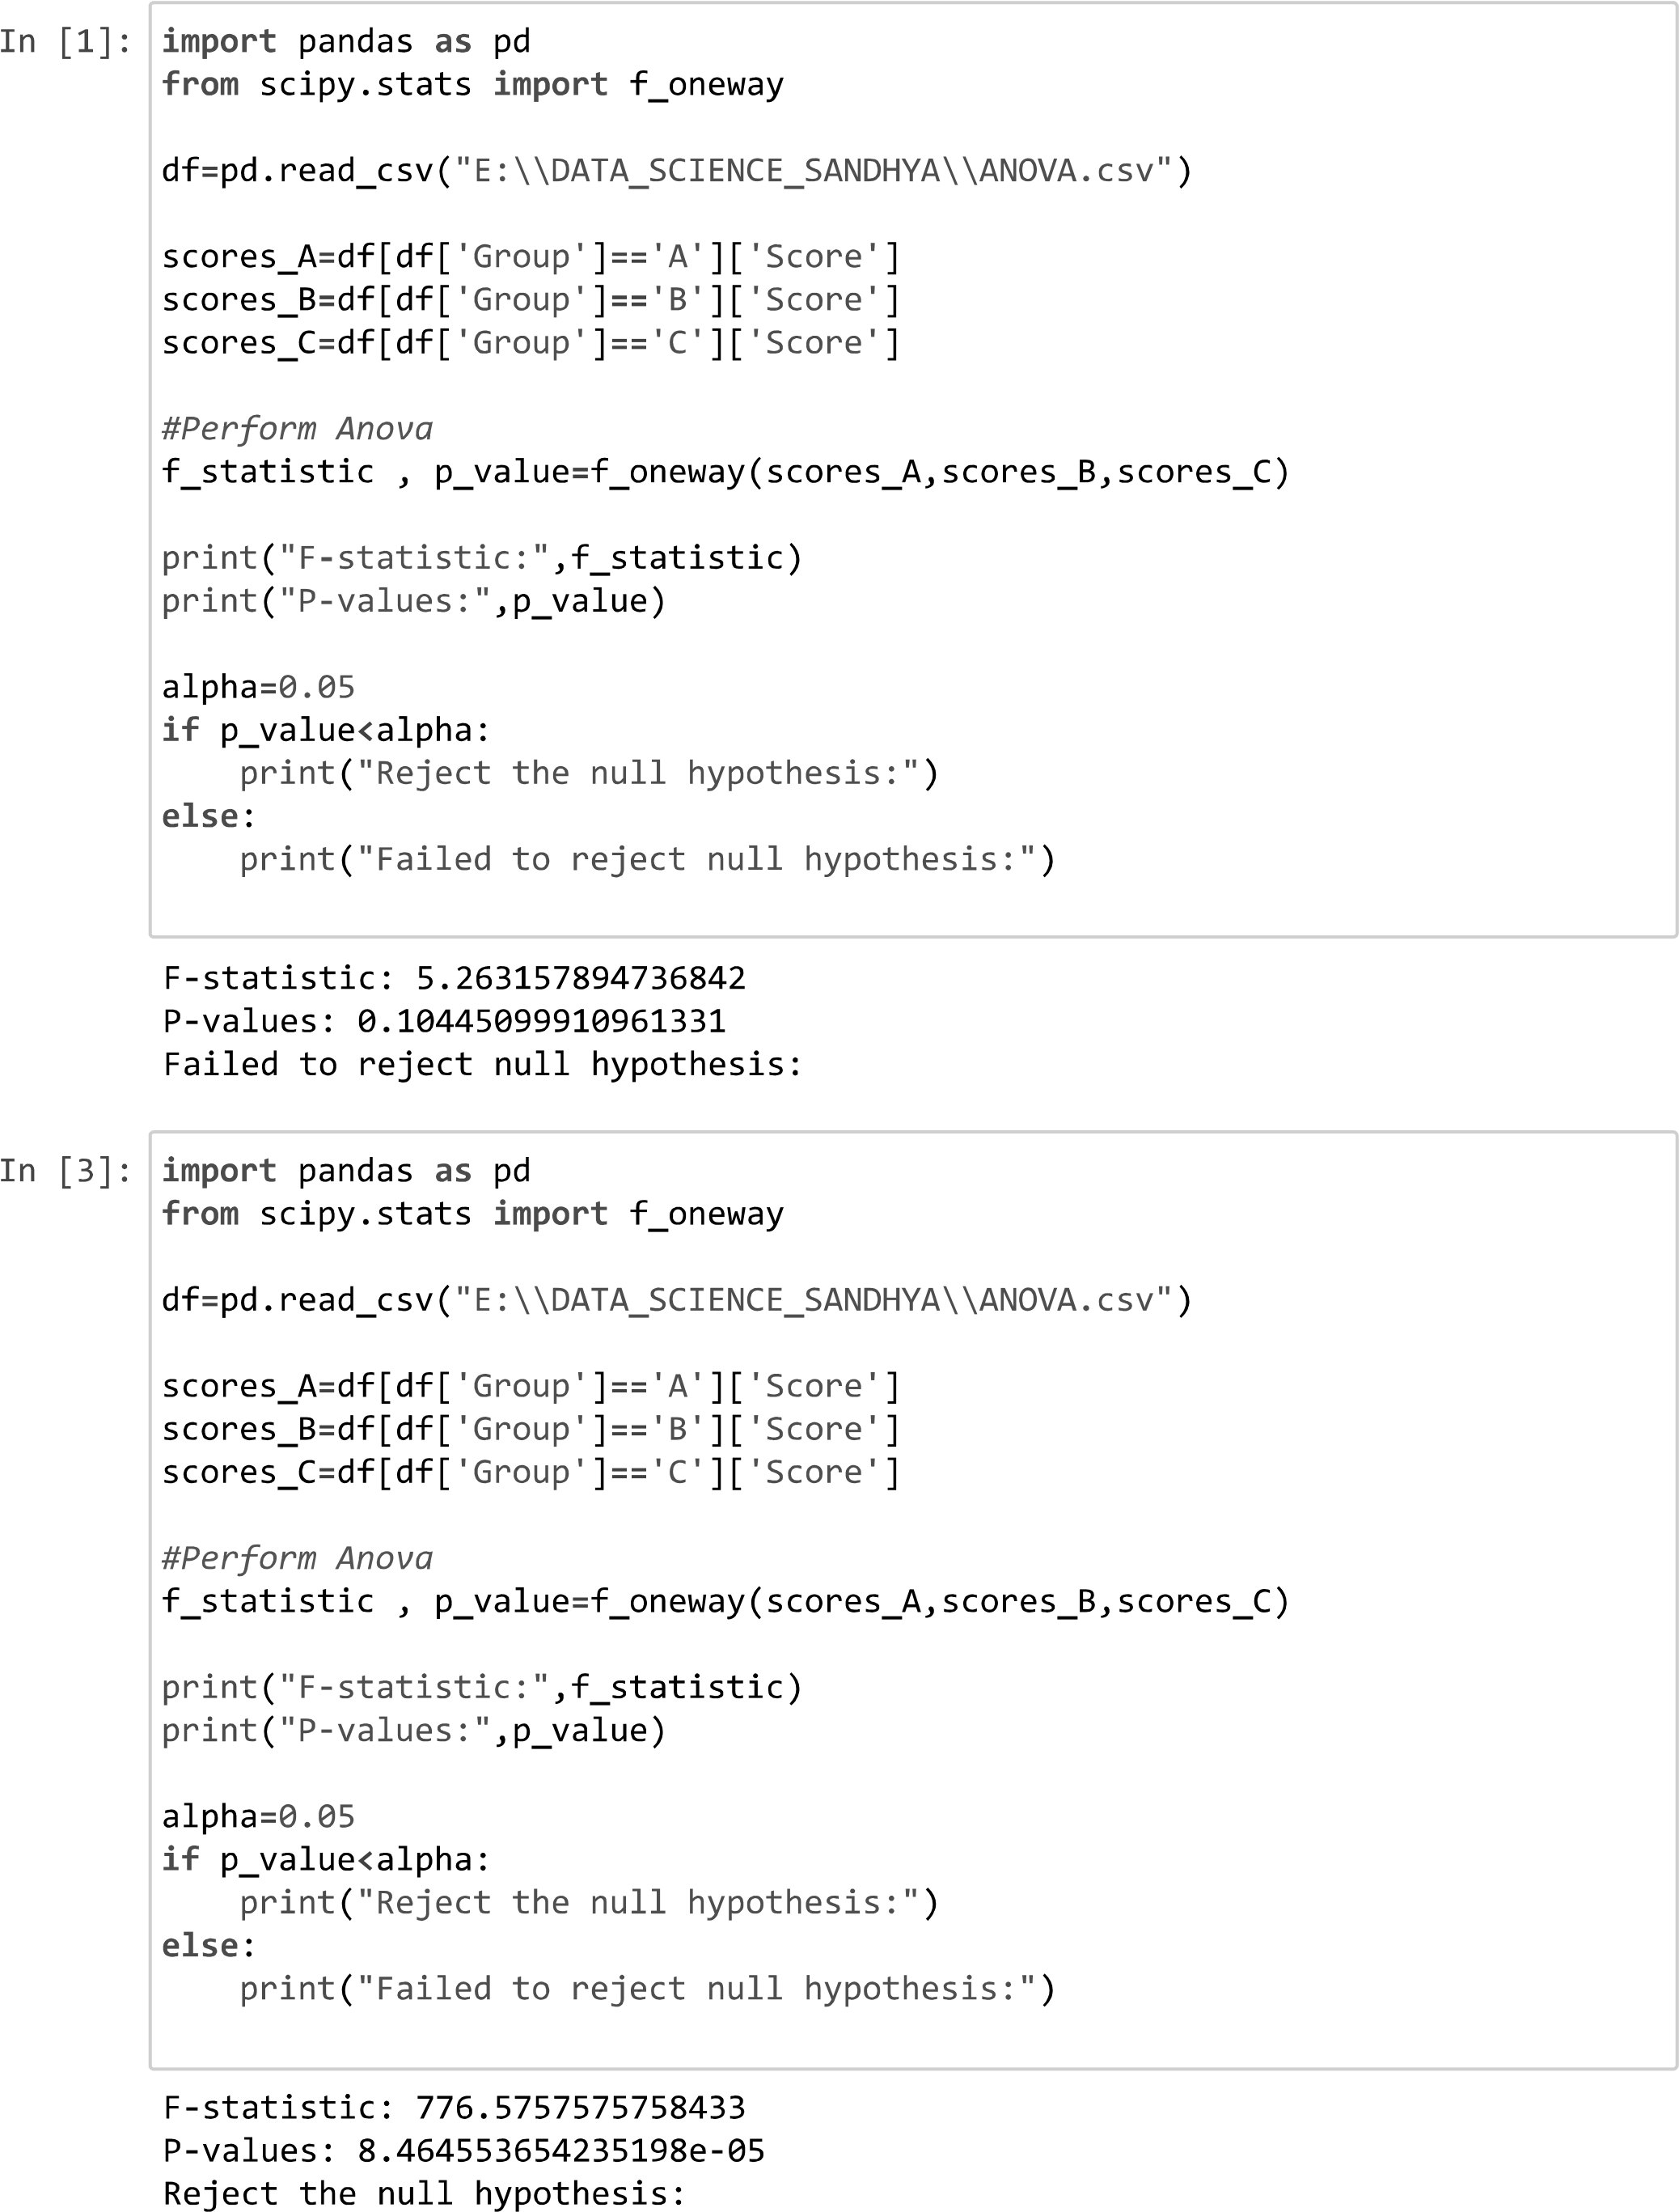

b) Conduct post-hoc tests to identify significant differences between group mean.

